**16 Nov 2018** **The Weekly Bulletin of Rotary Club of Kathmandu Mid-Town** **bc-9.11/018**

|  |
| --- |
| C:\Users\Public\Documents\RIP T1819_EN.png |

District: 3292 Web:www.rotarymidtown.org.np Club Id: 26776

**NOVEMBER IS ROTARY FOUNDATION** **MONTH**

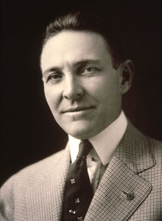

In 1917, RI President Arch C. Klumph proposed that an endowment be set up

‘for the purpose of doing good in the world.’ In 1928, when the endowment fund

had grown to more than US$5,000, it was renamed The Rotary Foundation, and it

became a distinct entity within Rotary International.

Five Trustees, including Klumph, were appointed to “hold, invest, manage, and

administer all of its property . . . as a single trust, for the furtherance of the purposes

of RI.”

Two years later, the Foundation made its first grant of $500 to the International

Society for Crippled Children.

PRI P Arch C. Klumph

**Club Meeting # 1463** : 2 Nov 018

Guest Speaker Dr. Kulesh B Thapa (Former DIG Police) IPP Bhai Raja Panday handing over a certificate of

giving a talk on sevices Nepal Ambulance Service provide. Appreciation to the guest speaker

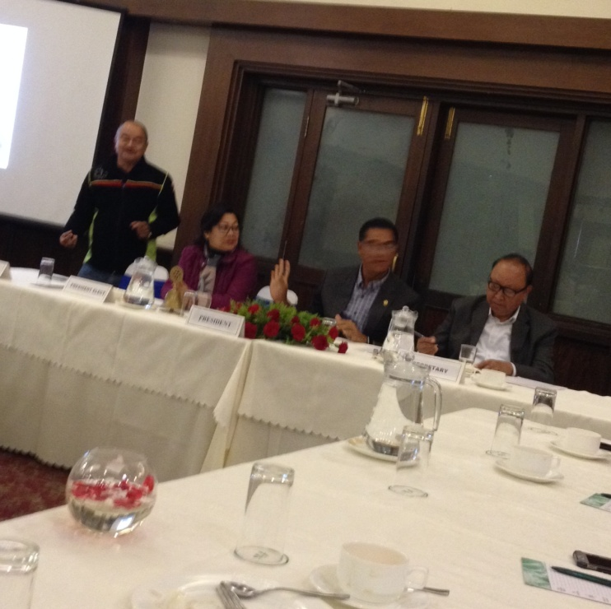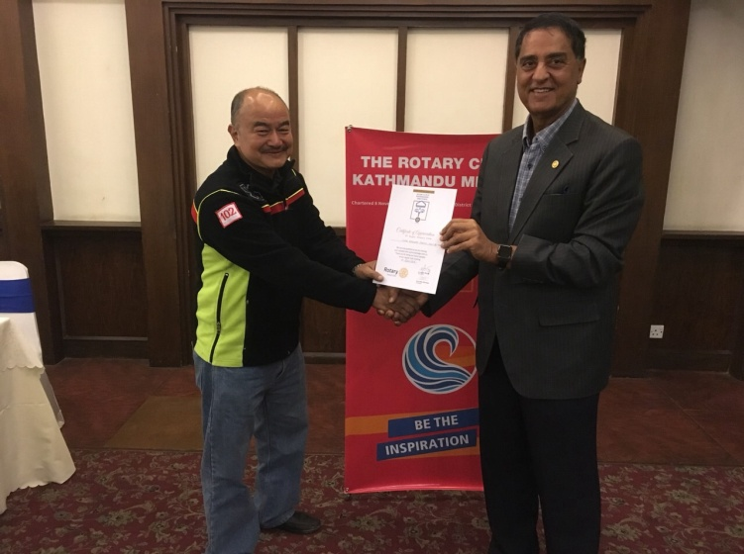

*Photo courtesy: Rtn Shyam R Thapalia*.

Welcoming visiting Rotarians from RC Nanaimo Daybreak & RC Campbell River, Canada in the Club meeting

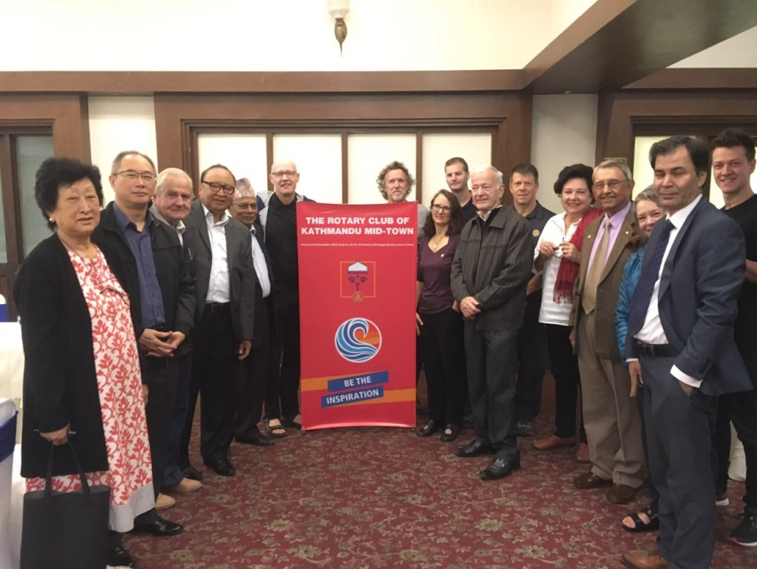

*Photo courtesy: Rtn Shyam R Thapalia*

and exchanging Club banners

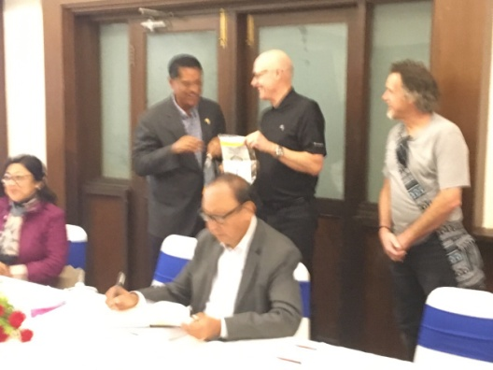 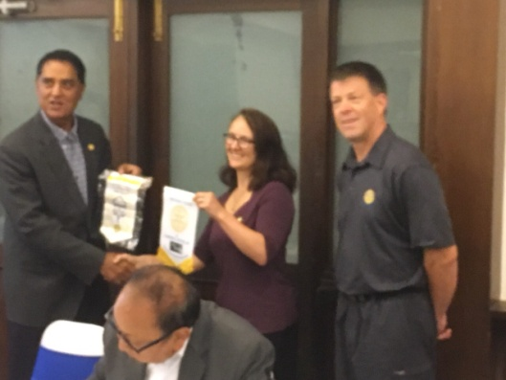

# Weekly Meeting/Program Schedule:

|  |  |  |
| --- | --- | --- |
| Date | Program/ Speaker | Topic of Presentation |
| 16 Nov 2018 | Charter Night | Charter Night celebration |
| 23 Nov 2018 | TBA |  |
| 30 Nov 2018 | TBA |  |
| 7 Dec 2018 | TBA |  |
| 14 Dec 2018 | Club Assembly |  |
| 22 Dec 2018 | DG Visit |  |

Friday 16 Nov

**Charter Night — the birthday party** **celebration**

****

To Rotary Club of Kathmandu Mid-Town

Charter Night celebration program is annexed.

**Vocational Training for Youth:**

Vocational Training Award and NAS Recognition Program’ witnessed the third phase of its training program. It concluded with felicitating patrons and certifying the students of Xavier’s Academy. Moderated by PE Neeva M Pradhan, the event was jointly organized in collaboration with NAS (Nepal Ambulance Service), Xavier’s College and Rotary Club of Kathmandu Mid-Town. The Emergency Medical Team from NAS (Nepal Ambulance Service), led by Dr Kulesh Bahadur Thapa, conducted the entire training program.Badal Pradhan, Principal of Xavier’s Academy, confirmed that the training was effectively informative as it exposed students to different interactive and hands-on sessions. “We look forward to encouraging students’ participation in such trainings in the future,” he added.

**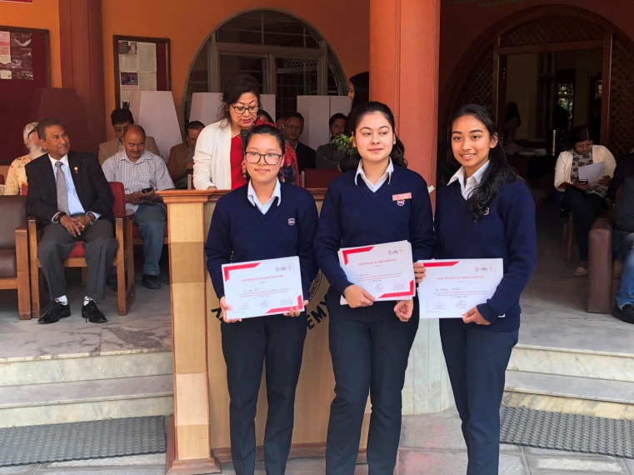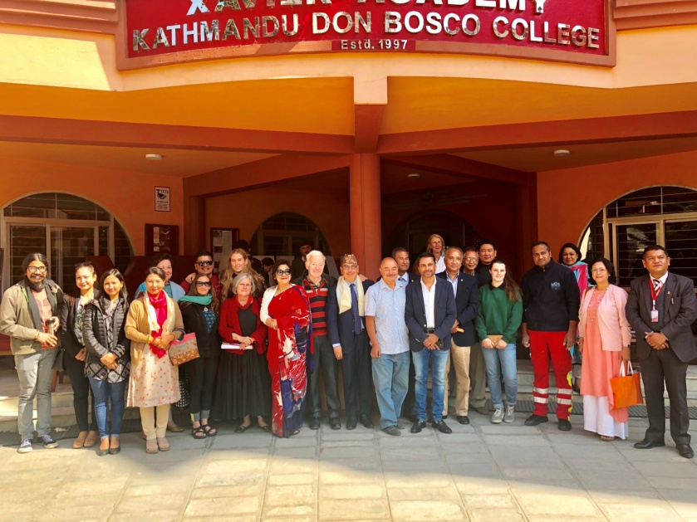**

*Photos: Facebook/Neeva Pradhan*

**Deusi Bhailo Program:**

In celebration of festive Tihar, Rotaract Club of Kathmandu Mid-Town organized a Deusi/Bhailo program held on Thursday 8 Nov 2018 at Osho World Travel Pvt Ltd, Thamel. Rotarian Shyam R Thapaliya co-sponsored and offered his office for the program. Many thanks to Rtn Shyam. The other co-sponsorers are President Jo and IPP Bhairaja Panday.

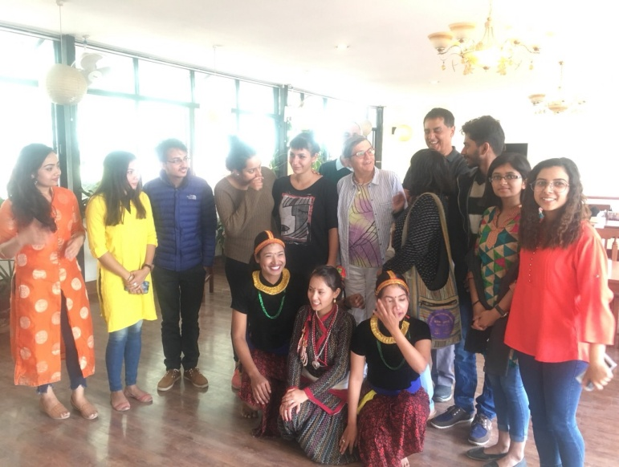 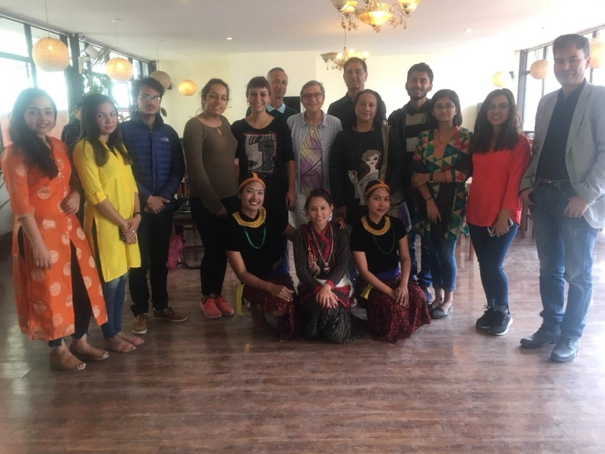

*Photo courtesy: Rtn Shyam R Thapalia*

**Committee Chairs’ Column:** *(This column is for use by chairpersons of 5 permanent committees: Club Administration, Membership, Public Relations, Service Projects, and the Rotary Foundation)*

**Members’ Corner:** *(This column is for Club members to express anything they would like in matter of Club activities, Club administration, Club issues or on Breakfast Chatter, or on anything else that would be of interest to fellow members.)*

PP Walter Diller’s email:

“Dear Neeva and Ranjit: Thanks and Congratulations.

Looks our club is on the way to keep us **really proud to be members**.”

*Source: Walter Diller/email*

**Do you know?**

To celebrate its 100th year, The Rotary Foundation has recognized 20 global grants that exemplify what a project should be. And one of the 20 is:

**Improving health services in Nepal with a VTT**

Area of focus: Fighting disease

Host sponsor: Rotary Club of Patan West, Nepal

International sponsor: Rotary Club of Amagasaki West, Japan

Total budget: $33,781

Background: Rotarians in District 2680 (Japan-Hyogo) have supported the Dr. Iwamura Memorial Hospital in Bhaktapur, Nepal, since it was established in 1998. Every month, the hospital treats 225 patients for emergency care and 1,300 outpatients. Rotarians saw a need for improved quality of services.

Scope: A vocational training team of an administrator and three nurses from the hospital received training on emergency care and dialysis treatment at Okamoto Hospital in Hyogo prefecture.

Impact: The training team members observed how Japanese hospitals receive and treat patients, learned best practices for infection management and safety procedures, and gained skills in dialysis treatment and the use of other advanced medical equipment.

*Source: Rotary.org*

**Rotary Foundation honored by University of Oxford**

The Rotary Foundation has been welcomed into the University of Oxford's Chancellor's Court of Benefactors for its continuous support of the university.

Since 1949, The Foundation has provided scholarships to more than 200 Oxford scholars including a former American ambassador to the United Kingdom, a Pulitzer Prize-winning author and investigative reporter with the New York Times, and a director and senior Fellow at the Ansari Africa Centre.

"The university is enormously grateful to The Rotary Foundation for their support of graduate scholarships at Oxford," said Professor Louise Richardson, vice-chancellor, University of Oxford. "For almost 70 years, this support has enabled students from around the world to benefit from all that Oxford has to offer." Membership of the Court of Benefactors is conferred by the chancellor on those who have been outstandingly generous towards the university.

Michael Webb, trustee of The Rotary Foundation, accepted membership on behalf of the Foundation on 11th October at a ceremony in Oxford. "The Rotary Foundation is honored to receive this designation and I am humbled to accept on its behalf," Webb said. "The Foundation has fostered international interaction and understanding through academic scholars at Oxford for decades, and we will continue our efforts to help develop the world's future leaders through academic support at this prestigious university." *Source: Rotary.org*

**A THOUGHT FOR TODAY:**

**Life never seems to be the way we want it but we live it the best way we can. There is no perfect life, but we can fill it with perfect moments.**

*Source: Facebook/Shiva Pradhan*

On Lighter Side:

Working people frequently ask retired people what they do to make their days interesting.

We try to have a little fun each day now that we're retired!

Well, here, an example:

The other day my wife and I went into town and went into a shop.

We were only in there for about 5 minutes.

When we came out, there was a cop writing out a parking ticket.

We went up to him and I said, 'Come on man, how about giving a senior citizen a break?'

He ignored us and continued writing the ticket. I called him a dumb ass. He glared at me and started writing another ticket for having worn tires.

So my wife called him a stupid insensitive shit head. He finished the second ticket and put it on the windshield with the first. Then he started writing a third ticket. This went on for some times, and the more we verbally abused him, the more tickets he wrote.

Just then our bus arrived!

We work to create lasting change — change for the good, change that will endure long after our

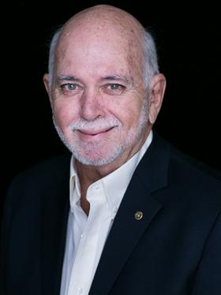

involvement has ended. Change across the globe, and in our communities — reaching out to those

we will never meet, and those closest to our hearts. And change in ourselves — perhaps most

important of all.

**RI President Barry Rassin**

Please send information on club activities, progress reviews on service projects, relevant photos etc to:

BC Editor: RR Shrestha email: rryesrr@gmail.com

## 16 Nov 2018 The Weekly Bulletin of Rotary Club of Kathmandu Mid-Town bc-9.11/018